# 

# **Department of Computer Science and Engineering Islamic University of Technology (IUT)** A subsidiary organ of OIC

# 

# **Laboratory Report**

# CSE 4412 : Data Communication and Networking Lab

## 

## **Name: Md Muktadir Mazumder Student ID: 190042136 Section: Group B Semester: 4th Semester Academic Year: 2021-22**

**Experiment No 8**

**Date of Submission: 17/03/22**

### **Title:** Understanding the concept of VLAN and configuration of VLAN to multiple user groups in different locations.

### **Objective**:

1. Understand VLAN
2. Configuration of VLAN

### **Devices Used In the Experiment**:

1. Device: Personal Computer

2. Software: Cisco Packet Tracer

### **Theory:**

**VLAN Definition**

VLAN is a custom network which is created from one or more local area networks.It enables a group of devices available in multiple networks to be combined into one logical network. The full form of VLAN is Virtual Local Area Network.VLAN is broadcast domain that is partitioned and isolated in a computer network at the data link layer (OSI layer 2). VLANs allow network administrators to group hosts together even if the hosts are not directly connected to the same network switch.

**Usage of VLAN:**

Explain the usage of VLAN with an example with three different user groups situated in three different levels of an office building.

**Uses of VLAN:**

VLANs address issues such as scalability, security, and network management. Network architects set up VLANs to provide network segmentation. Routers between VLANs filter broadcast traffic, enhance network security, perform address summarization, and mitigate network congestion.

**Usage of VLAN with an example:**

Let’s say our office building has three different levels. All the levels are connected with backlinks.

There are three departments: Development, Production and Administration.

Management department has three computers, production department has three computers and administration department also has two computers. Each level has two PCs from development department and one from both production and administration department. Administration and production department have sensitive information and needs to be separated from development department.With the default configuration, all computers share same broadcast domain. Management department can access the administration or production department resources.

With VLAN we can create logical boundaries over the physical network. Assume that we created three VLANs for our network and assigned them to the related computers:

* VLAN ADMIN for Administration department

* VLAN MANAGEMENT for Management department

* VLAN PRODUCTION for Production department

Physically we changed nothing but logically we grouped devices according to their function. These groups VLANs need router to communicate with each other. Logically our network look likes following diagram:

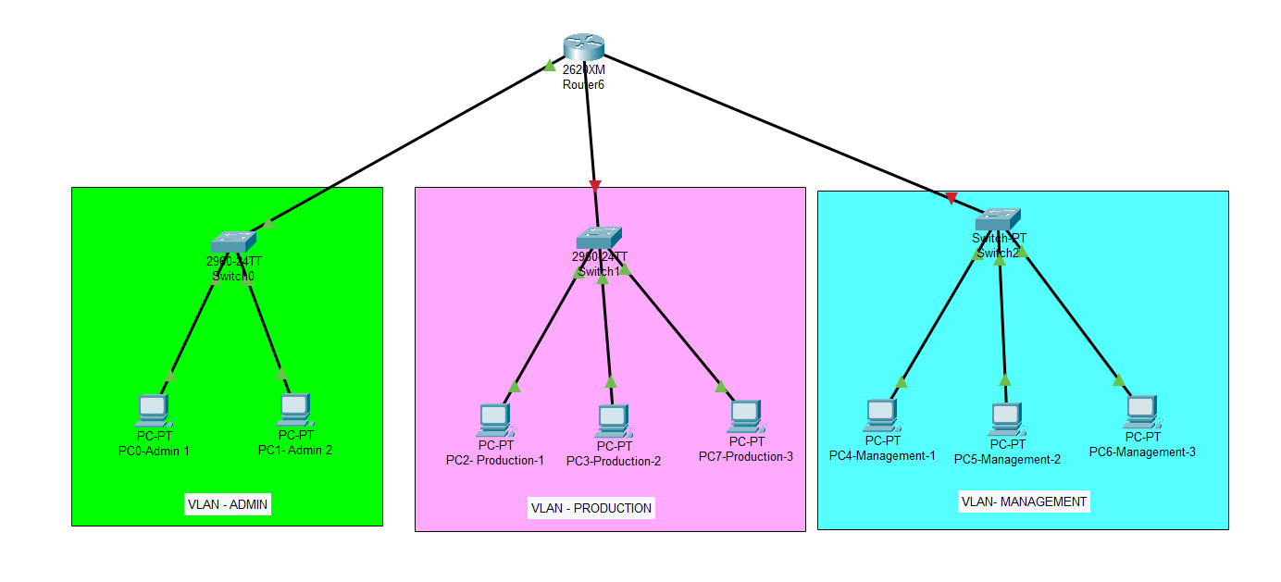

### 

### **Diagram of the experiment:**

### 

### **Configuration of different Switches:**

Commands for configuring VLAN

**For Switch 0:**

Switch>en

Switch#conf t

Switch(config)#vlan 20

Switch(config-vlan)#exit

Switch(config)#interface fa0/3

Switch(config-if)#switchport access vlan 20

Switch(config-if)#exit

Switch(config)#exit

Switch#show vlan

Switch#conf t

Switch(config)#interface fa0/4

Switch(config-if)#switchport mode trunk

Switch(config-if)#switchport trunk allowed vlan 1-99

Switch(config-if)#exit

**For Switch 1:**

Switch>en

Switch#conf t

Switch(config)#vlan 20

Switch(config-vlan)#exit

Switch(config)#interface fa0/2

Switch(config-if)#switchport access vlan 20

Switch(config-if)#exit

Switch(config)#interface fa0/1

Switch(config-if)#switchport access vlan 20

Switch(config-if)#exit

Switch(config)#exit

Switch#show vlan

Switch#conf t

Switch(config)#interface fa0/4

Switch(config-if)#switchport mode trunk

Switch(config-if)#switchport trunk allowed vlan 1-99

Switch(config-if)#exit

Switch(config)#interface fa0/5

Switch(config-if)#switchport mode trunk

Switch(config-if)#switchport trunk allowed vlan 1-99

Switch(config-if)#exit

**For Switch 2:**

Switch>en

Switch#conf t

Switch(config)#vlan 20

Switch(config)#vlan 97

Switch(config-vlan)#exit

Switch(config)#interface fa0/3

Switch(config-if)#switchport access vlan 97

Switch(config-if)#exit

Switch(config)#interface fa0/2

Switch(config-if)#switchport access vlan 20

Switch(config-if)#exit

Switch(config)#exit

Switch#show vlan

Switch#conf t

Switch(config)#interface fa0/4

Switch(config-if)#switchport mode trunk

Switch(config-if)#switchport trunk allowed vlan 1-99

Switch(config-if)#exit

### **Observation**:

The screenshots of ***show vlan*** command in two switches are shown below:

**For Switch2:**

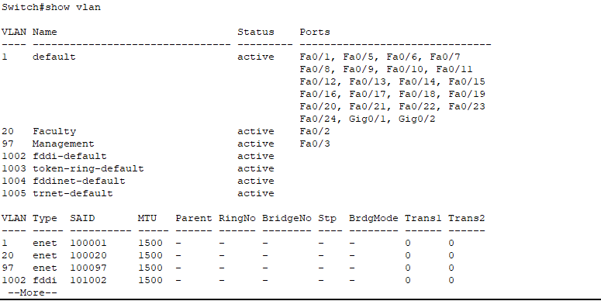

**For Switch1:**

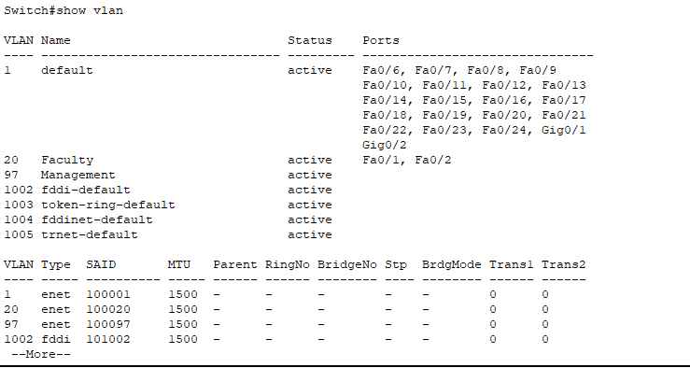

**For Switch0:**

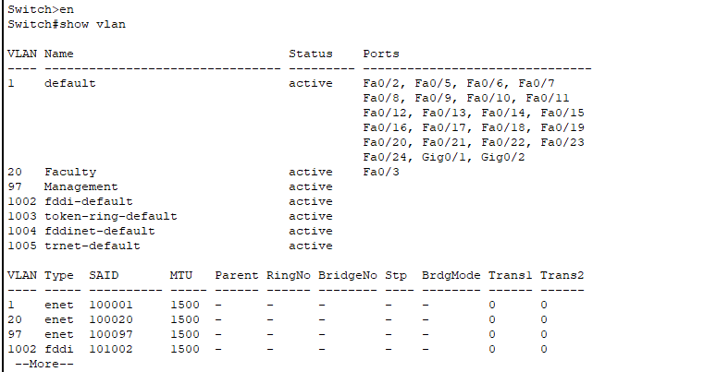

Screenshot of interface with trunk access using ***show running-config****:*

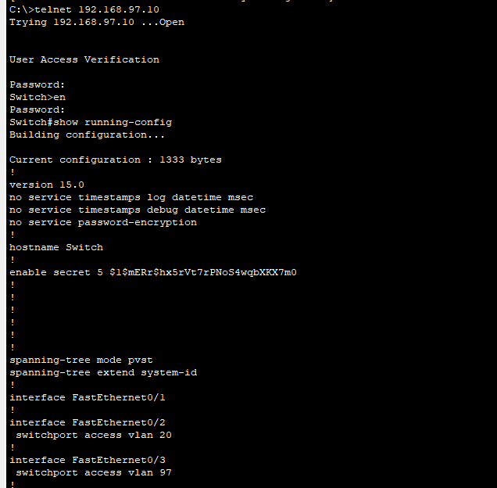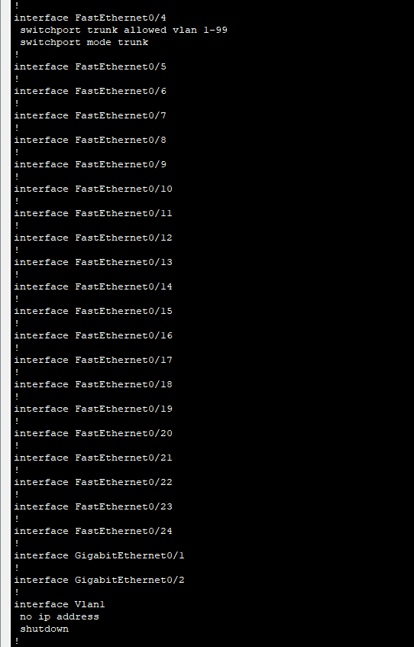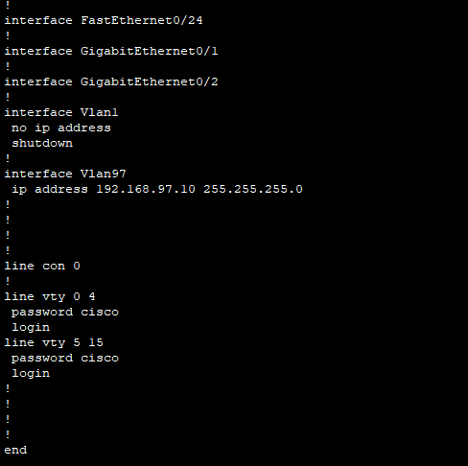

### **Challenges:**

Alhamdulillah, the experiment was done successfully. Problem was faced for assigning wrong IP address in PC7. After assigning the right one, vlan was show on the interface.

### 